REFUGEE BIODATA VERIFICATION APPLICATION PROGRAMMING INTERFACE (API) SYSTEM – TECHNICAL PROJECT REPORT

EXECUTIVE SUMMARY
The Refugee Biodata Verification Application Programming Interface (API) System is a secure, web-based platform designed to streamline the verification of refugee status and issuance of National Social Security Fund (NSSF) numbers in Uganda. The system allows authorized officials to efficiently verify refugee eligibility, access detailed personal records, and issue NSSF numbers for qualified individuals through a simple, intuitive interface.
By digitalizing these workflows, the system reduces manual email exchanges and reduces processing time from days to minutes, minimizes errors, and ensures that refugee records are accurate, secure, and compliant with national and international regulations.
Below is the link to the Github account containing a cloned repository.
https://github.com/NoelIkwap/B35094_MSDS_2025_ADVENT_OOP_Python_Programming

PROJECT OVERVIEW
Project Identification
- Project Name: Refugee Biodata Verification Application Programming Interface (API) System
- Deployment Environment: Web-based application
- Target Users: NSSF Staffs
Core Objectives
- Replace manual, email-based processes with automated, secure digital workflows.
- Ensure that refugee records are accurate and validated to prevent duplication and errors.
- Reduce verification and NSSF number issuance time from hours or days to minutes.
- Maintain adherence to Ugandan refugee regulations and international data protection standards.
- Support a growing refugee population with a robust and maintainable database architecture.

TECHNICAL ARCHITECTURE
Project Structure and Database Schema
refugee_flask_app/
_pycache_/
models.cpython-314
data/
nssf_issuance_log.csv
refugees.csv
verification_status.csv
instance/
refugee.db
routes/
_init_.py
refugee_routes.py
verification_routes.py
static/
css/
style.css
js/
script.js
templates/
404.html
base.html
case_details.html
index.html
verification.html
.env
app.py
config.py
create_db.py
create_table_data.py
insert_data.py
models.py
readme.md
refugees.db
requirements.text
update_country.py
System Architecture Diagram
The system follows a layered architecture to separate responsibilities and improve maintainability:

Presentation Layer
HTML5 │ CSS3 │ Bootstrap 5 │ JavaScript │ jQuery │ Swal2
(UI for verification, NSSF issuance, and user alerts)

Application Layer
Flask Web Framework (Python 3.14) | RESTful APIs & Business Logic
Handles validation, processing, and orchestration

Data Access Layer
SQLAlchemy ORM | Custom Python Models
Maps database tables → objects for querying & persistence

Data Storage Layer
SQLite (Development) | PostgreSQL (Production)
Stores refugee records, NSSF numbers, activity logs

This structure allows for modular development and ensures that the system can scale efficiently without compromising security or performance.

Primary Table: refugees
Check if details have been updated into the database by Going to your command line and typing “cd C:\Users\Admin\Documents\refugee_flask_app” so you can navigate to the actual project folder.
Open SQLite in Terminal by running “sqlite3 refugees.db”
Check if table exists by typing “.tables”
The name of my table is refugees and to be able to view some rows I typed this command. “SELECT * FROM refugees LIMIT 10;”
And below is the screenshot of the results. I was able to generate over 10,000 random records for all the columns to work with since I could not access a live environment and I also found it hard to find datasets to work with.
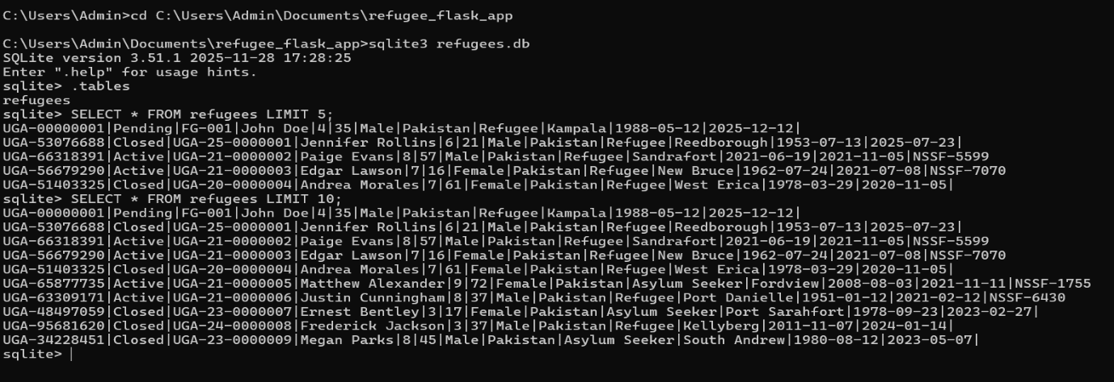
Some of the random individual numbers include.
UGA-00000001
UGA-53076688
UGA-66318391
UGA-56679290
UGA-51403325

RESPONSIVE DESIGN SPECIFICATIONS AND ILLUSTRATIONS FROM THE ACTUAL APPLICATION
Pictorial explanation of the user interface and how it works with the logic embedded in the application can be shown in the below narrations. This Includes HTML layout, input validation, and responsive design. The UI responds dynamically to; Invalid cases, Minors (age < 18), Closed process status, Asylum seekers (ineligible),Already-issued NSSF numbers and Verified eligible refugees

Landing Page
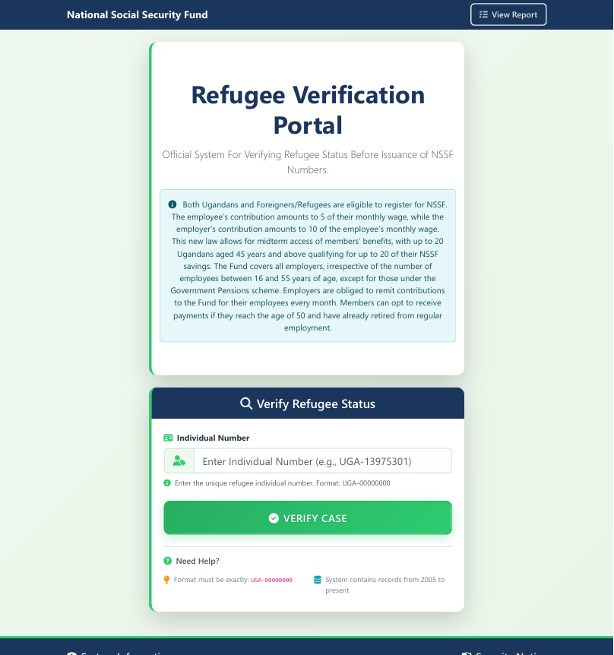
Enter individual number.
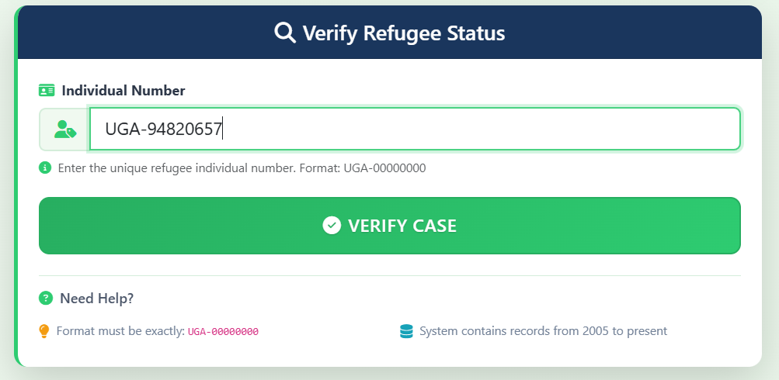
If the case is Active (process_status) and legal_status is an Asylum seeker it displays “case found -Asylum seeker and since Asylum seekers are not eligible for NSSF Numbers, it says “individual is not eligible for NSSF Number because he is an asylum seeker, asylum seekers must complete the refugee status determination process. It rejects the case nevertheless.
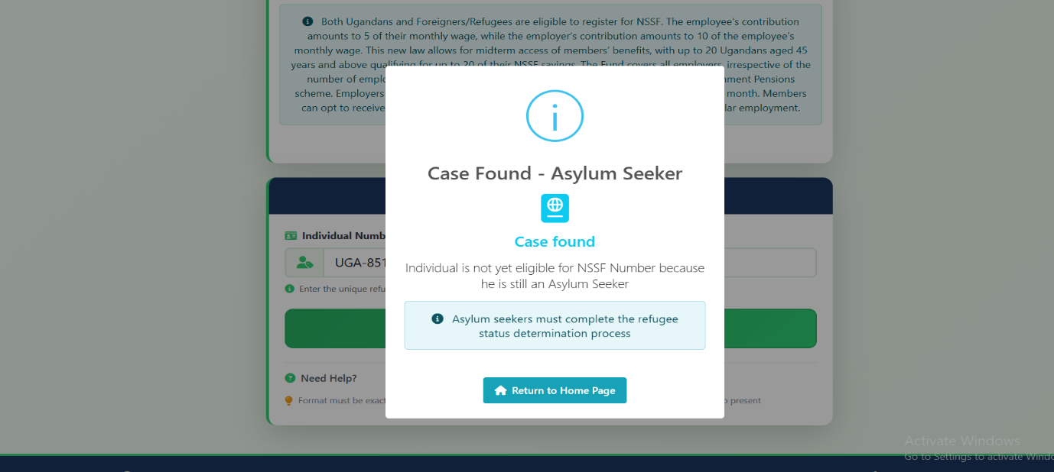
If the case has a process status of closed, irrespective whether they are refugees or asylum seekers, it rejects the case and returns a message saying individual is nolonger a refugee in Uganda. Process status is closed meaning they nolonger enjoy protection of the Ugandan government hence they do not qualify for any services in Uganda including NSSF. Snapshot below shows that pop-up.
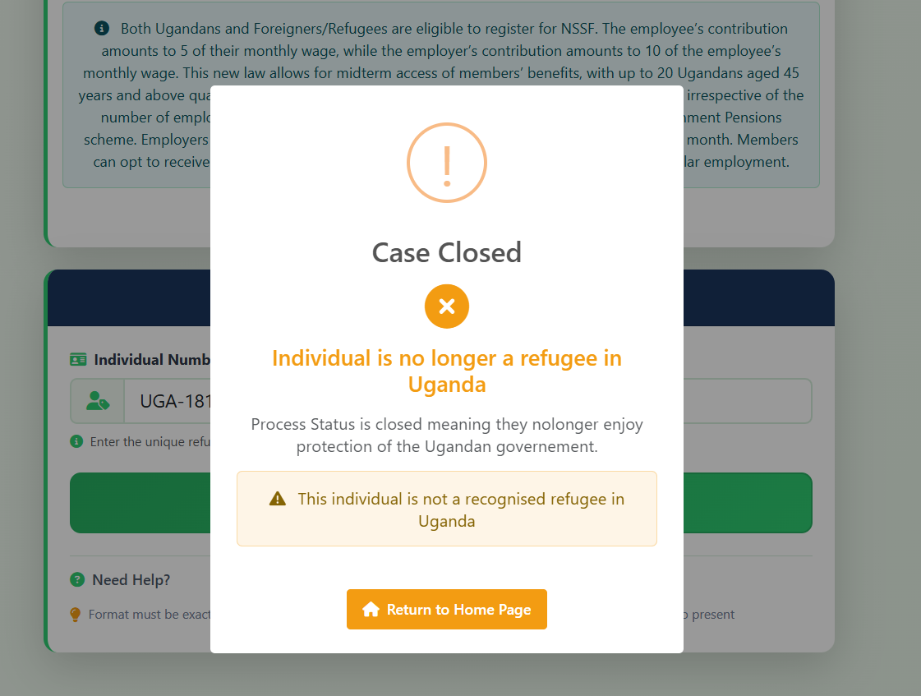
If the case has been found, it displays a pop-up showing verification Successful and notifes the staff thatthe individual is a recognised Active refugee in Uganda and that the individual is legible for NSSF services and prompts the user to either close or show personal information for more confirmation.
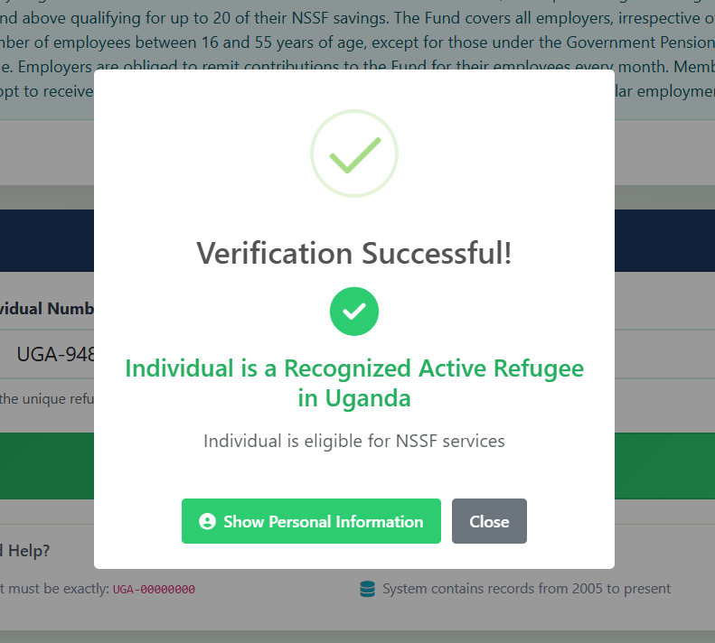
The screenshot below shows the personal information for verification and clearly shows the the NSSF number has not yet been issued. And promopts the user to proceed and issue Nsssf number or return to the home page.
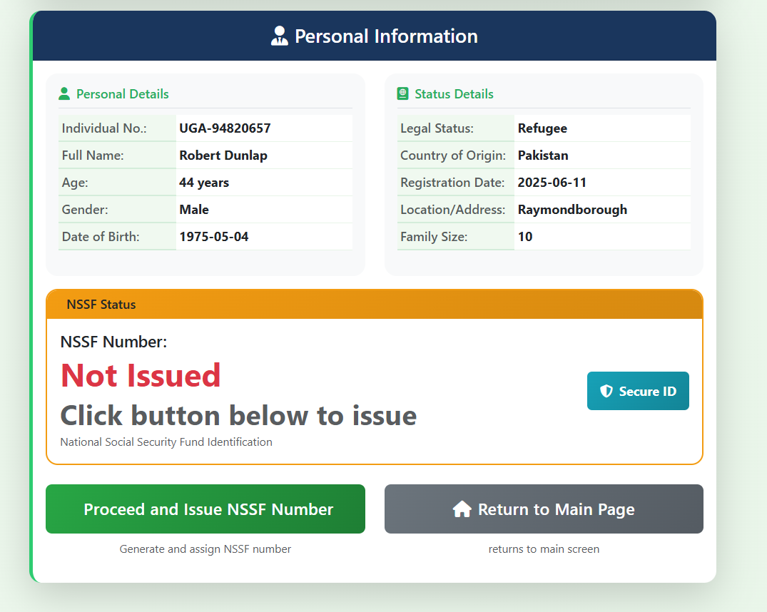
If the nssf number has already been issued, it will show that NSSF number already issued and it will deactivate the Proceed to issue NSSF button to prohibit the user from proceeding.
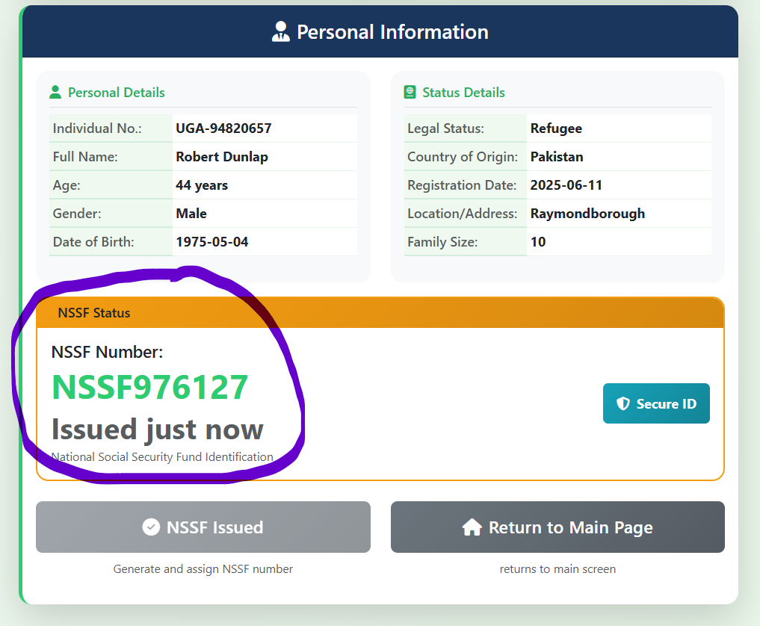
If the client is active and a refugee but is below the age of 18, it will reject issuance of Nssf number stating that the client is a minor and is below the age of 18 and deactivate the proceed to issue nssf number button it will also highlight the age line on the personal details table clearly stating minor as seen below.
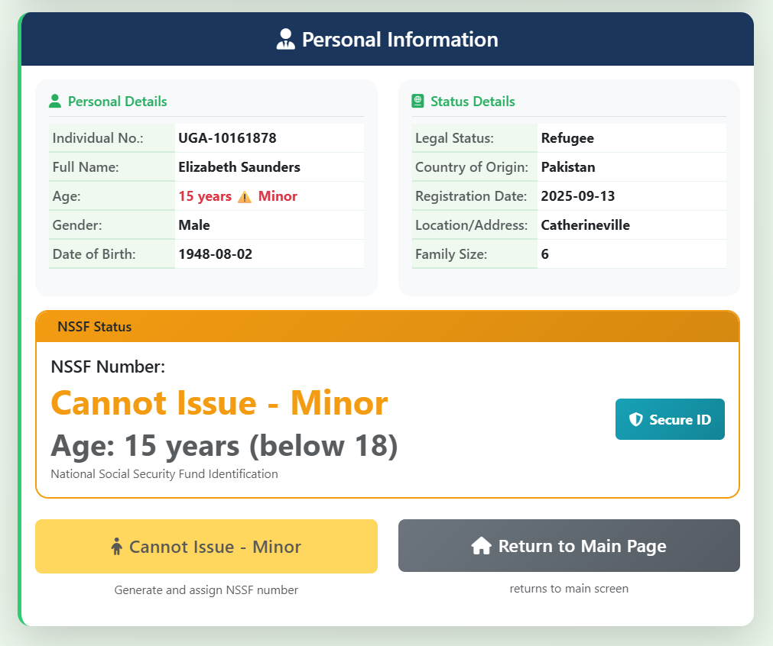
If everything is fine, it will proceed and issue the NSSF number accordingly below are screenshots of the last parts of the system.
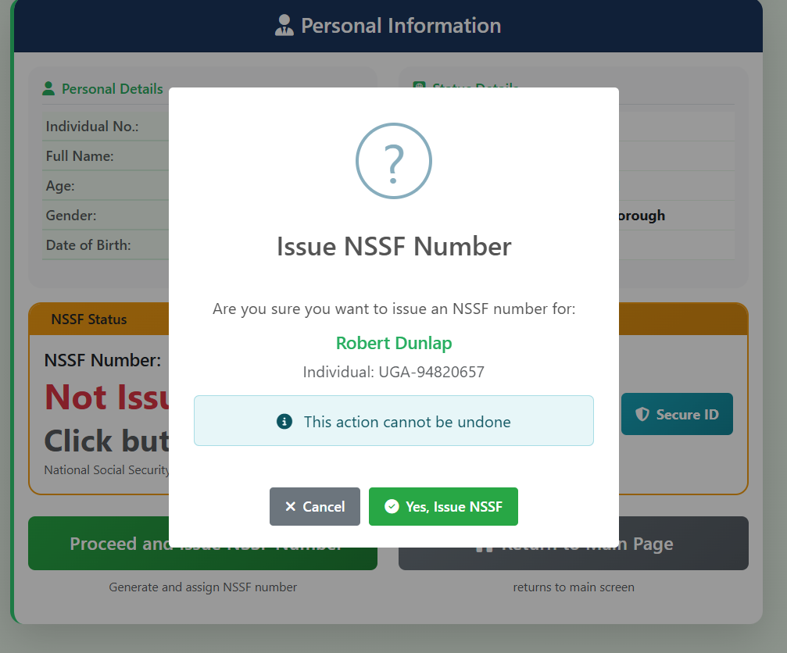
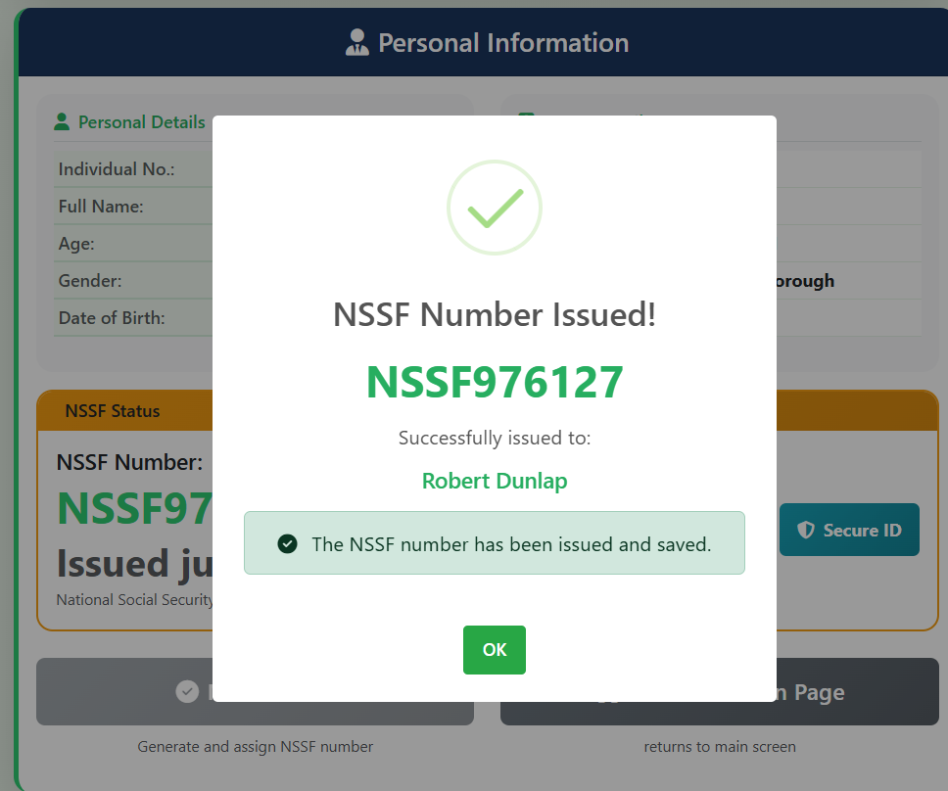
Incase one needs to view the number of cases issued with Nssf numbers, they can click the view report link at the top right corner of the application to view the report and the report will be displayed as seen below.
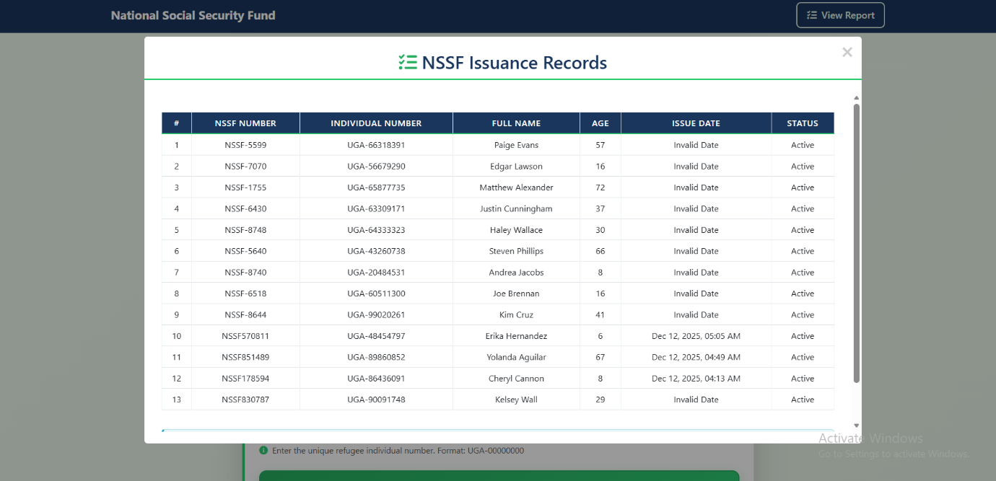

DEPLOYMENT ARCHITECTURE
Production Stack:
├Web Server: Nginx 1.22+
├Application Server: Gunicorn 20.1+
├Database: PostgreSQL 14+ / MySQL 8+
├Cache: Redis 7+
├File Storage: AWS S3 / DigitalOcean Spaces
└Monitoring: Prometheus + Grafana

MONITORING & MAINTENANCE
Key Performance Indicators
- Uptime: 99.9% SLA
- Response Time: < 2 seconds
- Data Accuracy: 100% verification accuracy
Maintenance Schedule
- Daily: Database backups, log rotation
- Weekly: Security updates, performance optimization
- Monthly: Full system audit, data integrity checks
- Quarterly: Major updates, feature enhancements

COMPLIANCE & REGULATIONS
- Uganda Data Protection Act (2019)
- UNHCR Data Protection Policy
- ISO 27001 Information Security Management

REFERENCES
[1] H. Tshirhart, Tkinter GUI Application Development: Develop exciting and engaging GUI applications in Python and Tkinter by working on 10 real-world applications. Birmingham, UK: Packt Publishing.
[2] A. Downey, Think Python: How to Think Like a Computer Scientist, 2nd ed., Version 2.4.0. Needham, MA: Green Tea Press.
[3] A. Pajankar, Python Unit Test Automation: Practical Techniques for Python Developers and Testers. Birmingham, UK: Apress.
[4] A. B. Downey, Python for Software Design: How to Think Like a Computer Scientist. Olin College of Engineering.
[5] M. Summerfield, Programming in Python 3: A Complete Introduction to the Python Language, 2nd ed. Addison-Wesley.
[6] G. Dwyer, Flask by Example: Unleash the Full Potential of the Flask Web Framework by Creating Simple Yet Powerful Web Applications. Birmingham–Mumbai: Packt Publishing.
[7] I. Maia, Building Web Applications with Flask: Use Python and Flask to Build Amazing Web Applications, Just the Way You Want Them. Birmingham–Mumbai: Packt Publishing.

Submitted by Name: Noel Ikwap
Access Number: B35094
Registration Number: S25M19/017
Class: Master of Science in Data Science and Analy cs

